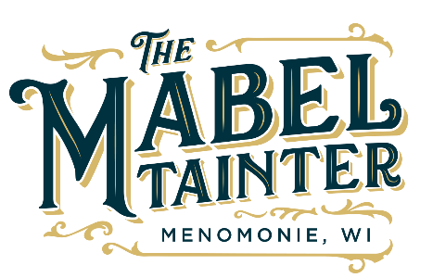

The Mabel Board of Directors Meeting Agenda
The Mabel Tainter mission is to strengthen and connect our community by engaging people in the arts.

If a guest wishes to attend a board meeting, call 715-235-0001 or email director@mabeltainter.org
2 weeks prior to attending the meeting

November 16th, 2021 at 7:00pm
Mabel Tainter Stage

Call to order Andrew Mercil
Approval of Minutes
Director’s Updates Lucas Chase

Committee Report
- Facilities Ryland
- Finance/Treasurer’s Report Andrew
- Marketing Tammy
- Programming Lucas
- Finance Committee Mike

Old Business
- Investment Policy
- 2022 Budget
- Mabel Bar

New Business
- Mabel Tech Upgrades
- December Holiday Meeting
- Stout Board Member discussion
Other
Adjournment

MEMBERS (X = present; O = absent)
_ __Andre, Emily
___ Ascher, Emily
____Asher, Ashley
_ __Braatz, Mike
_ __Buhr, Audric
___ Erdman, Ryland
___ Fox, Juliet (Vice President)
___ Kneeland, Melissa (Secretary)
___ Leisses, Tammy
____Ludwig, Trevor
___ McNally, Paul
___ Melchionne, Natasha
_ __ Mercil, Andrew (President)

___ Chase, Lucas – Int. Executive Director

